DHS-4469-ENG 11-16
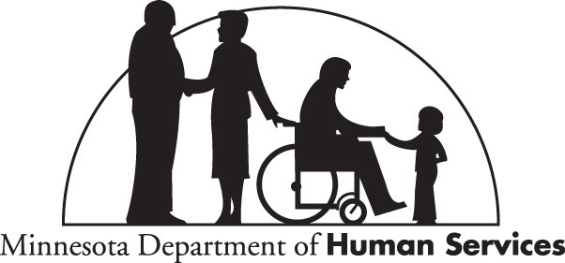

Dear Agency Representative,
As an agency that provides services to Minnesota Health Care Programs (MHCP) recipients, you must submit this enrollment application and provider agreement for each individual personal care assistant (PCA). This will:
- Assign a Unique Minnesota Provider Identifier (UMPI) to the PCA
- Allow you to bill us for the services the PCA provides
To enroll PCAs with us, the individual PCA must:
- Read and understand the Privacy Notice
- Pass the Background Study (BGS)* per PCA program requirements and be affiliated to the agency's BGS facility ID
- Successfully complete and pass the required PCA training competency test
- Meet the provider screening requirements
- Correctly complete the application
- Sign the application
- Read and sign the MHCP Provider Agreement - Individual Support Worker (PCA, CDCS and CSG) (DHS-4611)

A new DHS BGS must be completed if the PCA has not been continuously employed with your agency.
*Complete a DHS BGS by logging in to the NetStudy website at https://bgs.dhs.state.mn.us/a/login.asp and follow directions.
More information is on the MHCP Provider webpage at www.dhs.state.mn.us/provider.

Fax the application and agreement to 651-431-7465. MHCP accepts only faxed applications and agreements.

Clear Form

Minnesota Health Care Programs (MHCP)
DHS-4469-ENG 11-16

Individual PCA Enrollment Application
Complete this form online, print and then fax to MHCP. Complete at least all bolded fields to enroll an individual PCA. We will return incomplete forms to you.
IMPORTANT: If you are not able to complete this form online, click Print Blank Form to print the form and complete it by hand.
Print Blank Form

New hire (requires new background study and completion of PCA training) Rehire (requires new background study and completion of PCA training)
Previously used for managed care organization (MCO) claims only (new background study not required)

Individual PCA Information

PROVIDERTYPE  38 – INDIVIDUAL | LEGALNAME(FIRST) |  | FULL MIDDLENAME |  |  | LASTNAME |  |  |  | SOCIALSECURITY NUMBER
ADDRESS (RESIDENTIAL ADDRESSONLY– DONOTENTERA POBOX) |  |  |  | CITY |  |  |  |  | STATE | ZIPCODE
COUNTYOFRESIDENCE |  | PHONENUMBER |  |  | DATEOFBIRTH |  |  | UMPI (if requesting reinstatement)
INDIVIDUALPCA TRAINING  DATEPASSED: CERTIFICATION NUMBER: |  |  |  |  |  |  | Is the individual 18 years old or older?  Yes No* *May affiliate with only one agency
If previously used for MCO only claims, has this individual maintained continuous employment with your agency? Yes No |  |  |  |  |  |  |  |  | BGS NUMBER or APPLICATION ID
Individual PCA Provider Statement
I have reviewed and certify the information provided above is true and correct to the best of my knowledge. I will notify the Minnesota Department of Human Services Provider Enrollment of any additions or changes to the information.
By signing this form, I acknowledge I have read and understand the Application and Background Study Privacy Notice. I also authorize the Minnesota Department of Human Services to use the information collected about me according with the Privacy Notice.

NAMEOFPCA (print or type) | SIGNATUREOFPCA | DATESIGNED

Group Affiliation Information
You have the option to affiliate or enroll the individual PCA named above, if 18 years old or older, with other agencies you directly own without completing another application and agreement. Do you want to affiliate the above named individual PCA with any other agencies you own? Yes No

Page 1 of 2

Agency Information

AGENCYNAME  LIVE WELL MN HOME HEALTHCARE |  | AGENCYNPI ORUMPI  A253694000 | AGENCY FAX NUMBER  952-303-5273
AGENCYPERSONNELCOMPLETINGFORM  Isaak Osman Rooble | AGENCYSIGNATURE
Next Steps
Read, sign and date the MHCP Provider Agreement - Support Worker (PCA, CDCS and CSG) (DHS-4611), and return it with this application.
Fax the application and agreement to 651-431-7465. Only faxed requests will be processed.

Page 2 of 2 DHS-4469-ENG 11-16

